INTRODUCTION:

PROJECT TITLE: CRYPTOVERSE

TEAM MEMBERS:

D.DIVYA (212205224)

S.JANANI (212205241)

J.KOWSALYA (212205260)

S.MONIKA (212205266)

TEAM MEMBERS ROLES:

D.DIVYA – DOCUMENTATION EDITOR

S.JANANI – CONTENT PROVIDER

J.KOWSALYA – PROGRAM OUTPUT RUNNER

S.MONIKA – VOICE OVER

PROJECT OVERVIEW

**PURPOSE:**

The "cryptoverse" refers to the collective universe of cryptocurrencies, blockchain technologies, decentralized applications (dApps), and related concepts. Its purpose can be seen in several key areas:

1. **Decentralization**: The cryptoverse aims to remove intermediaries like banks, governments, or large corporations from financial systems, enabling peer-to-peer transactions directly between users.
2. **Financial Inclusion**: By providing accessible and decentralized financial services, the cryptoverse aims to offer banking and investment opportunities to people who are unbanked or under banked, especially in regions with limited access to traditional financial systems.
3. **Security and Privacy**: Block chain technology, a core part of the cryptoverse, provides strong encryption and transparency, ensuring that transactions are secure and tamper-resistant. Cryptocurrencies also aim to give individuals more control over their personal data and financial information.

**FEATURES:**

* **Core Features**: List the key features of the project. For example:
  + Cryptocurrency transactions
  + Decentralized finance (DeFi) functionalities
  + NFT creation and marketplace
  + Staking & Yield farming
  + Smart contract automation
* **User Interface**: Describe the user experience and interface (web, mobile, etc.), and any features for ease of use.
* **Security Measures**: Explain how your project ensures secure transactions and protects user data (e.g., encryption, two-factor authentication, etc.).

**ARCHITECTURE**

* **System Overview**: A high-level diagram showing how the various components of the project interact (e.g., front-end, smart contracts, blockchain network, user wallets, etc.).
* **Smart Contracts**: Provide details about the smart contract architecture and the code if open source. Include explanations of the functions and how they interact.
* **Consensus Mechanism**: Explain the consensus mechanism your blockchain utilizes (e.g., Proof of Work, Proof of Stake, Proof of Authority).
* **Interoperability**: Discuss how your project interacts with other platforms or blockchains (e.g., cross-chain capabilities, token bridges).

**SETUP INSTRUCTION**

* Create a Cryptocurrency Wallet
* Sign Up for the Cryptoverse Platform
* Connect Your Crypto Wallet
* Set Up Preferences and Customize
* Purchase Virtual Assets (Optional)
* Explore and Interact
* Secure Your Account

**FOLDER STRUCTURE**

### ****1.Root Directory:****

Contains configuration files, documentation, and basic setup for the entire project.

bash

Copy

/cryptoverse/

|-- README.md # Documentation for the project

|-- .gitignore # Git ignore settings for unnecessary files

|-- .env # Environment variables (for private keys, etc.)

|-- package.json # Node.js dependencies and scripts

|-- truffle-config.js # Truffle configuration (if using Truffle for smart contracts)

|-- hardhat.config.js # Hardhat configuration (if using Hardhat for smart contracts)

|-- /docs # Project documentation, guides, and FAQs

|-- /scripts # Automation scripts (e.g., deployment scripts, migrations)

### 2. ****Smart Contracts:****

This folder contains all the blockchain-related code, such as smart contracts, migrations, and contract ABIs.

bash

Copy

/contracts/

|-- /src/

| |-- Token.sol # Example smart contract (e.g., ERC-20 token)

| |-- Staking.sol # Example staking contract

| |-- Governance.sol # Example governance contract

|-- /migrations/ # Migration scripts for deploying contracts

| |-- 1_deploy_contracts.js

| |-- 2_upgrade_contracts.js

|-- /build/ # Compiled contract artifacts (created by Truffle/Hardhat)

|-- truffle-config.js # Truffle configuration file

|-- hardhat.config.js # Hardhat configuration file (if using Hardhat)

### 3. ****Frontend (DApp):****

This folder contains the frontend code for the DApp (React, Vue, etc.) that interacts with the blockchain.

bash

Copy

/frontend/

|-- /public/

| |-- index.html # Main HTML page

| |-- /assets/ # Static assets like images, fonts

|-- /src/

| |-- /components/ # React components (Header, Footer, etc.)

| |-- /hooks/ # Custom React hooks for blockchain interaction

| |-- /utils/ # Utility functions (e.g., Web3 helpers)

| |-- App.js # Main React component

| |-- index.js # Entry point for the frontend

|-- package.json # Node.js dependencies for the frontend

|-- webpack.config.js # Webpack configuration (for bundling)

### 4. ****Backend (Optional - for server-side logic or API):****

If your project needs backend services (e.g., an API to handle transactions, user accounts, etc.), the backend folder holds that code.

bash

Copy

/backend/

|-- /src/

| |-- /controllers/ # API controllers (e.g., userController.js)

| |-- /models/ # Database models (e.g., user.js, transaction.js)

| |-- /routes/ # API routes (e.g., blockchainRoutes.js)

| |-- /services/ # Business logic services (e.g., transactionService.js)

| |-- app.js # Main backend app (express or other framework)

|-- /config/ # Configuration files (e.g., DB, API keys)

|-- package.json # Node.js dependencies for the backend

|-- server.js # Server entry point

**RUNNING THE APPLICATION**

### 1.****Clone the Repository:****

### First, if you haven’t already, clone your ****Cryptoverse**** repository to your local machine:

bash

Copy

git clone https://github.com/your-username/cryptoverse.git

cd cryptoverse

### 2. ****Set Up Smart Contracts****

If your **Cryptoverse** project includes smart contracts, you need to compile, deploy, and migrate them to a local blockchain (using Truffle or Hardhat). You also need to ensure that the contracts are properly set up and configured.

#### ****With Truffle****:

* **Install Dependencies**: First, install Truffle globally and the project dependencies.

bash

Copy

npm install -g truffle

npm install

* **Start Ganache**: If you are using **Truffle**, start **Ganache** (a personal blockchain) to test the contracts locally. If you haven't installed Ganache, you can download it here.

You can also use **Ganache CLI** for command-line use.

bash

Copy

ganache-cli --deterministic

* **Deploy the Contracts**: Once Ganache is running, deploy your contracts:

bash

Copy

truffle migrate --network development

#### ****With Hardhat****:

* **Install Dependencies**: For Hardhat, install the necessary packages:

bash

Copy

npm install --save-dev hardhat

npm install

* **Start the Hardhat Network**: Start a local Hardhat network to deploy contracts.

bash

Copy

npx hardhat node

* **Deploy the Contracts**: Once the network is running, deploy your contracts.

bash

Copy

npx hardhat run scripts/deploy.js --network localhost

### 3. ****Frontend (DApp)****

Once your smart contracts are deployed and you have the ABI (Application Binary Interface) for interacting with them, you can run the frontend (DApp). The frontend will communicate with the blockchain via **Web3.js** or **Ethers.js**.

#### ****Frontend Setup****:

* **Install Frontend Dependencies**: Inside the /frontend directory, install the required dependencies.

bash

Copy

cd frontend

npm install

* **Configure Web3 or Ethers**: Make sure the frontend is properly configured to connect to the blockchain (local or testnet). Update web3.js or ethers.js to point to your local Ganache or Hardhat node.

Example for **Web3.js** (in /frontend/src/utils/web3.js):

js

Copy

import Web3 from 'web3';

const web3 = new Web3('http://localhost:8545'); // Local Ganache or Hardhat network

export default web3;

Or with **Ethers.js**:

js

Copy

import { ethers } from 'ethers';

const provider = new ethers.JsonRpcProvider('http://localhost:8545'); // Local Hardhat node

export default provider;

* **Start the Frontend**: Once the configuration is done, start the frontend development server.

bash

Copy

npm start

The frontend (e.g., React app) should now be running, usually on http://localhost:3000, and it should be able to interact with your deployed contracts.

Copy

vercel deploy

**COMPONENT DOCUMENTATION**

**KEY COMPONENTS:**

* ConnectWalletButton Component
* TokenBalance Component
* StakeForm Component
* TransactionHistory Component

**REUSABLE COMPONENTS:**

* Wallet Connection Button
* Token Balance Display
* Transaction Button
* Staking Form

**STATE MANAGEMENT**

• **User Wallet State**: The user's wallet connection (whether it’s connected or not, wallet address, etc.).

• **Global State**: Data that needs to be shared across multiple components, such as network details (mainnet, testnet), token balances, and user information.

**USER INTERFACE**

**1. Wallet Interfaces**

* **Purpose**: Allow users to manage their crypto assets (like Bitcoin, Ethereum, etc.), view balances, and send or receive transactions.
* **Examples**: MetaMask, Trust Wallet, Coinbase Wallet.

**2.Decentralized Exchange (DEX) UIs**

* **Purpose**: Provide platforms for users to trade cryptocurrencies without intermediaries, using smart contracts on blockchains.
* **Examples**: Uniswap, SushiSwap, PancakeSwap.

**3. DeFi Platforms**

* **Purpose**: Decentralized financial applications for lending, borrowing, staking, and yield farming.
* **Examples**: Aave, Compound, Yearn.finance.

**4.NFT Platforms**

* **Purpose**: Enable users to buy, sell, and trade digital collectibles, art, and other assets as NFTs.
* **Examples**: OpenSea, Rarible, SuperRare.

**5.Governance Platforms**

* **Purpose**: Platforms that allow users to participate in governance decisions of decentralized projects or DAOs (Decentralized Autonomous Organizations).
* **Examples**: Snapshot, Aragon.

**STYLING**

**1.Minimalism and Clarity**

* **Purpose**: Blockchain platforms often deal with complex data and transactions, so minimalist design helps reduce cognitive overload.
* **Key Elements**:
  + **Flat Design**: Avoids 3D elements and excessive decorations to focus on function.
  + **Whitespace**: Provides breathing room between elements, making it easier for users to focus on important actions (e.g., sending crypto or confirming transactions).

**2.Color Schemes and Branding**

**Purpose**: Color schemes in crypto apps often follow branding guidelines to create identity, while also considering psychological factors like trust, security, and engagement.

* **Key Elements**:
  + **Blue and Green Tones**: These colors are commonly used for trust and stability (e.g., Binance, Coinbase). Green often symbolizes safety, like "success" or "transaction complete."
  + **Dark Mode**: Many platforms, like **MetaMask**, **Uniswap**, and **DeFi** apps, use dark themes. It not only reduces eye strain but also helps highlight important elements and buttons in light contrast.

**3.Typography**

* **Purpose**: Typography helps in legibility and establishing the tone of the platform. In crypto platforms, clarity is vital for trust and understanding.
* **Key Elements**:
  + **Readable Fonts**: Using sans-serif fonts like **Roboto** or **Montserrat** ensures text is clear and modern.
  + **Font Hierarchy**: Differentiating between headings, subheadings, and body text to guide users and make key information stand out.

**TESTING**

* **Smart Contract Testing**
* Blockchain Network Testing
* Decentralized Application (dApp) Testing
* User Acceptance Testing (UAT)
* Security Testing
* Performance Testing
* **Regression Testing**

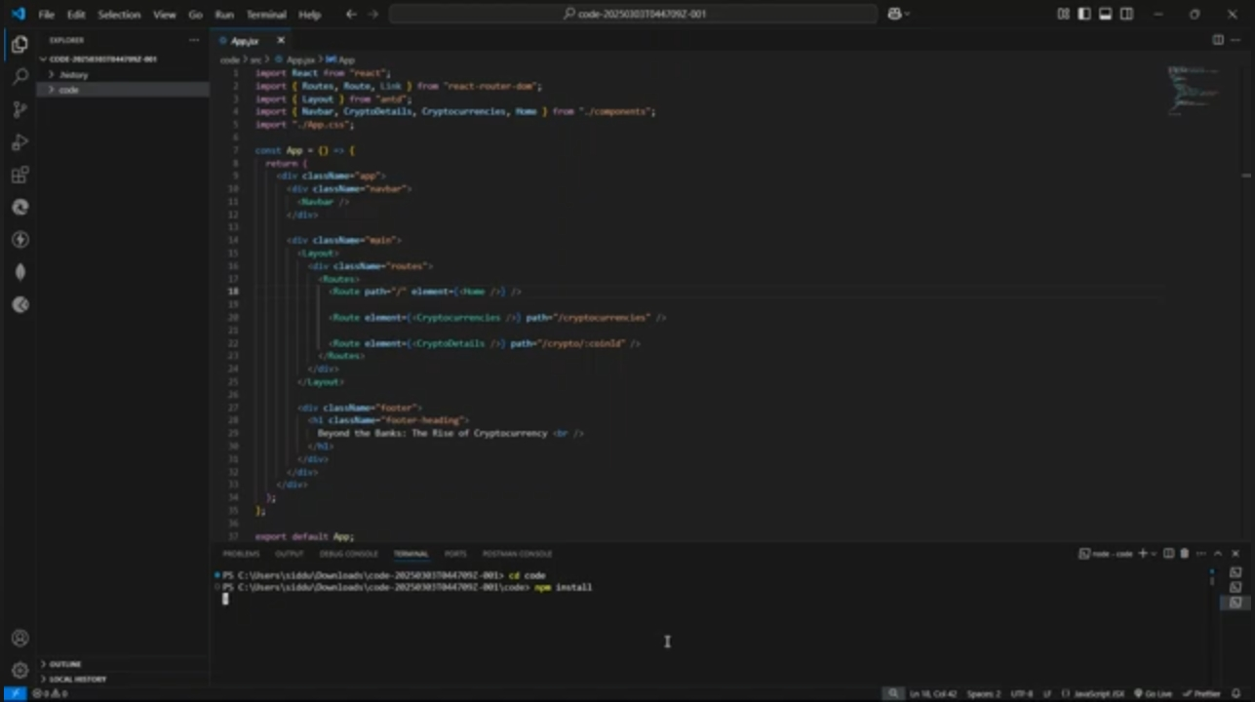**SCREENSHOTS OR DEMO**

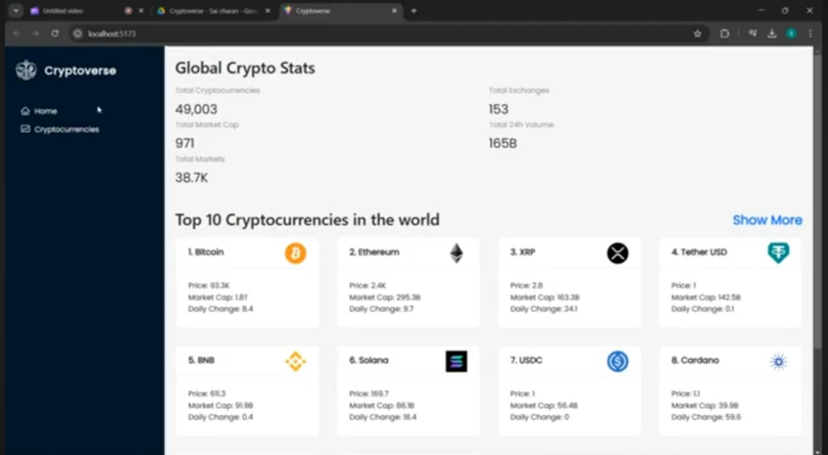

**KNOWN ISSUES**

* Security Risks & Hacks
* Regulatory Uncertainty
* Scalability & High Fees
* Market Volatility & Manipulation
* Environment Impact

**FUTURE ENHANCEMENTS**

**1.Interoperability and Cross-Chain Solutions**

* **Current Challenge:** Cryptocurrencies and blockchain projects are often siloed, making it difficult to transfer assets or data between different platforms.
* **Future Enhancement:** Solutions like **Polkadot**, **Cosmos**, and **Chainlink’s Cross-Chain Interoperability Protocol (CCIP)** are paving the way for better interoperability. This will allow seamless interactions between different blockchains, making it easier to transfer assets and data across various networks.

**2. Scalability Improvements**

* **Current Challenge:** Many blockchains struggle with scalability, leading to slow transaction speeds and high fees.
* **Future Enhancement:** Technologies like **Ethereum 2.0 (Proof of Stake)**, **sharding**, and **Layer 2 solutions** (e.g., **Optimism**, **Arbitrum**, and **Polygon**) are expected to significantly improve scalability, making blockchain systems faster and more efficient.

**3. Privacy Enhancements**

* **Current Challenge:** Public blockchains like Bitcoin and Ethereum offer transparency, but this can compromise user privacy.
* **Future Enhancement:** Privacy-focused technologies such as **Zero-Knowledge Proofs (ZKPs)** and **zk-SNARKs** are gaining traction. These allow transactions to be verified without revealing sensitive information. Projects like **Zcash**, **Monero**, and **Aztec Protocol**.